Module 2
EXAMPLE OF A CHAIN OF SIGNIFICANT EVENTS AND TRANSITIONAL OUTCOMES
Project for modifying bus service in an urban neighbourhood.

Context – Neighbourhood X is an underprivileged urban neighbourhood with a high population density, but poorly served by public transit. It has few bus routes and the buses don't run very often. Grocery stores are located far from where people live. As a result, for grocery shopping, people tend to turn to convenience stores where fruit and vegetables are rare. In addition, the food items are more expensive and of lower quality than in supermarkets. Since local residents have limited means of transportation within this area that public health officials term a "food desert", this issue has become a major challenge to social development.
The Community Intersectoral Committee held a forum on local social development to identify priorities for local action, which resulted in a document of strategic directions (event #1). This document outlines three priorities, including Healthy Environment and Healthy Lifestyles. One of the objectives is to promote access to affordable fresh fruit and vegetables.
Events Transitional outcomes
Event #1 Production of Intermediaries (TO # 4)

To achieve this objective, the Committee set up a Sub-Committee for Access to Fruits and Vegetables (event #2). The committee is composed of members of the public, community organizations, city representatives, public health officials, and the development corporation representing store owners for the main commercial artery in the neighbourhood.
Events Transitional outcomes
Event #2 Network Creation (TO #1)

To develop a shared understanding of the issue, the Access Committee produced a map of food sources (event #3) in Neighbourhood X. With the map in hand, the committee consulted residents and organized an evening discussion about food (event #4), which improved the quality of the mapping by adding to it the perspectives of members of the public. This increased the credibility of the Access Committee, which presented and defended the project's relevance to various official bodies.
Events Transitional outcomes
Event #3 Production of Intermediaries (TO #4)
Event #4 Strengthening of Spokespersons and Intermediaries (TO #8)

During the meeting, some citizens pointed out that one of the grocery stores in the next neighbourhood was 12 blocks away from the #30 bus route that provides a way for residents of neighbourhood X to get downtown. Various solutions were brought up, including having the #30 bus run past the grocery store. This would allow the residents in neighbourhood X—most of whom do not have cars—to take the bus to the grocery store. The Access Committee drafted a summary of the solutions brought up during the consultation (event #5).
Events Transitional outcomes
Event #5 Production of Intermediaries (TO #4)

Several months later, after many discussions and having taken stock of the situation, the Access Committee asked for and got the City Transit Commission (CTC) to take part in a discussion about local public transit service (event #6).

The needs expressed by members of the general public were put forward during this discussion. The summary of the courses of action identified during the consultation was handed out and explained to the City Transit Commission representatives (event #7).

Events Transitional outcomes
Event #6 Representation by Spokespersons (TO #7)
Event #7 Placement of Intermediaries (TO #5)

The City Transit Commission, whose action plan is citizen-focused, was open to the needs expressed (event #8), which were well articulated with respect to overcoming neighbourhood isolation and having access to supermarkets in order to maintain a proper diet.
Events Transitional outcomes
Event #8 Alignment of Interests – Movements of Actors (TO #9)

In the following year, the City Transit Commission committed to changing the #30 bus route (event #9).
Events Transitional outcomes
Event #9 Commitment of Decision-Makers in Achieving Change (TO #12)

The City Transit Commission changed the bus route to have it run near the grocery store and increased the frequency of buses.
Effects on the living environment:
Bus route modified, which increased access to the grocery store.

At the start of the workshop At the end of the workshop

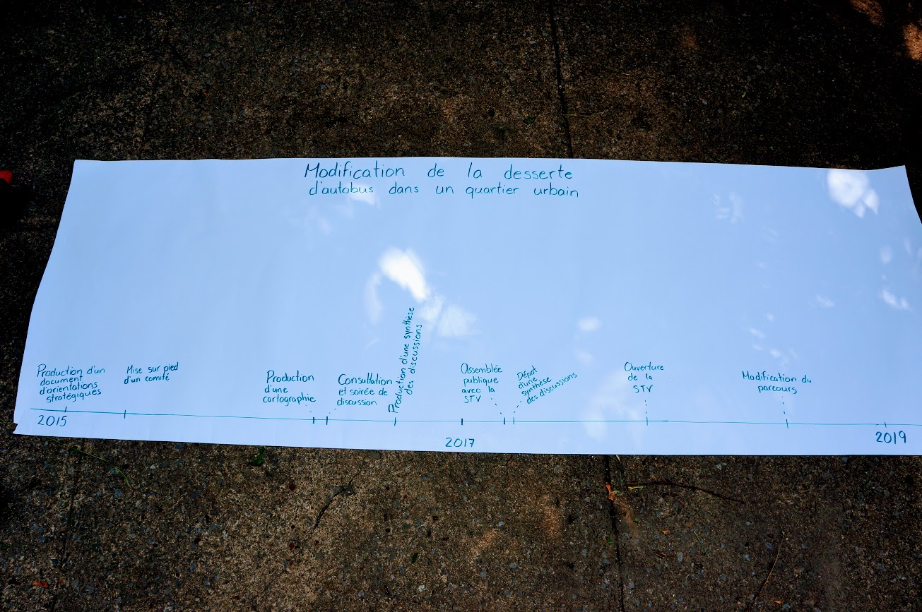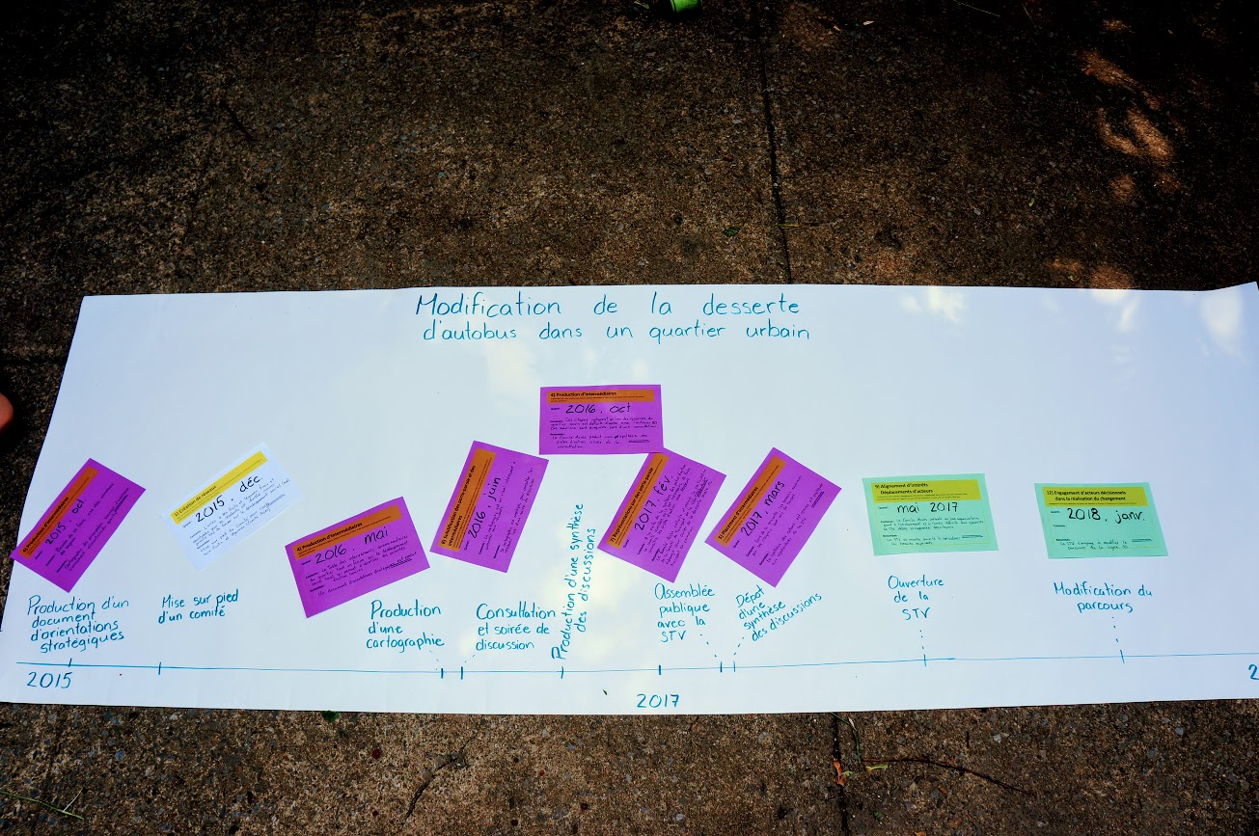

This is a fictional example. To consult the case studies: http://chairecacis.org/fichiers/publications/2017-11-29rapport_pat_final.pdf; http://chairecacis.org/fichiers/publications/2017-11-29rapport_ltqhm_final_0.pdf; http://chairecacis.org/fichiers/publications/2017-11-29rapport_centre-sud_final.pdf

