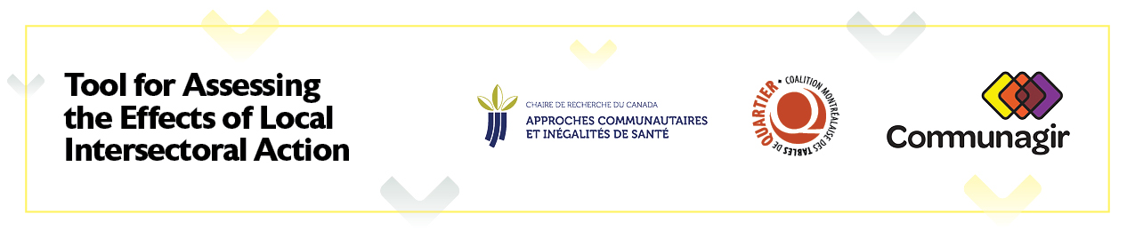
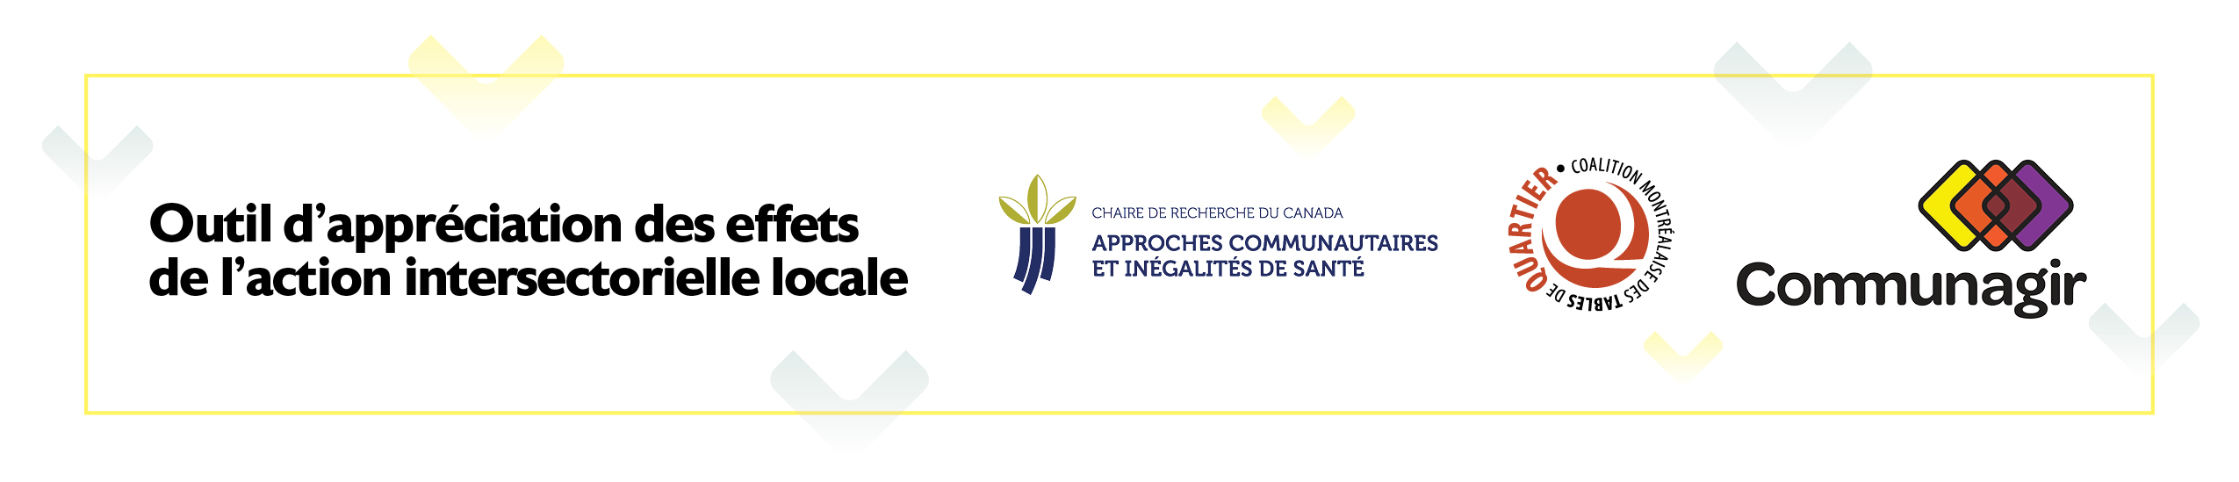

Module 2
Feedback Form
Mapping the key events of a project and translating them into a chain of transitional outcomes

This grid is intended to determine your level of satisfaction with the workshop. All responses will be treated confidentially. Do not indicate your name. Thank you for taking the time to complete it, which should only take 5 minutes.
- Mark one box for each item.
Overall Appreciation: | Strongly  agree | Agree | Disagree | Strongly  disagree
I enjoyed this workshop.
It was relevant for the project and my organization.

The location and time were suitable.
General comments:

- Mark one box for each item.
The workshop allowed you to: | Strongly  agree | Agree | Disagree | Strongly  disagree
Identify, based on the project's story, the key events leading to observable effects in living environments.
Link these events to a more general theory that identifies 12 generic transitional outcomes.
Comments:

- Mark one box for each item.
The workshop met: | Strongly  agree | Agree | Disagree | Strongly  disagree
your expectations
your needs
Comments:

- Mark one box for each item.
The facilitator: | Strongly  agree | Agree | Disagree | Strongly  disagree
Knew the subject thoroughly.
Listened to and took into account the group.

Grasped the project's and the partnership’s reality.

Comments:

- Mark one box for each item.
Follow-Up: | Strongly  agree | Agree | Disagree | Strongly  disagree
I would like to add events to the story.
I would like to take part in another meeting to further explore transitional outcomes.

I would like to take part in a meeting to learn from the chain of transitional outcomes in order to reinvest them in the action.

I would like to further explore the actor–network theory in Module 1.

I recommend this workshop to other intersectoral action bodies.

Comments:

Thank you for participating!

